RENEWABLE ENERGY FOR TWEEDSMUIR – OVERVIEW

The potential for renewable energy projects in Tweedsmuir falls into two categories:

1. Systems for individual homes or small, geographically adjacent groups of properties

These systems would generate electricity which is used directly by the properties, with any excess power being sold to the national grid. There are a variety of potential types of renewable energy generation which could be used:
- Solar (photovoltaic cells)
- Solar absorption (roof panels to pre heat water into your heating system)
- Biomass (burning wood or wood pellets in a boiler)
- Ground-source heat system
- Water-source heat system
- Small wind turbine
- Small hydro-turbine system

2. Larger scale systems which feed directly into the national grid, providing an income for the whole area

These systems are considerably larger but could provide an income which could be distributed to all households to contribute to the energy costs for all homes.

The four systems appropriate for a large-scale project of this type would be:

(a) Hydro-turbine systems which make use of the energy potential of our greatest asset – water!

Hydro-turbine systems work by using the energy created by water moving from higher ground to lower ground to power turbines which generate electricity. The amount of energy produced depends on how far the water is falling (known as 'head') and the amount of water going through the turbines.

The place nearby with the most potential is the burn above Talla Linfoots, which drops approximately 120 meters from the bridge at the top to the reservoir.

You can see the sort of thing we could expect at the following web site:
http://www.gilkes.com/case-studies/Kilnstones
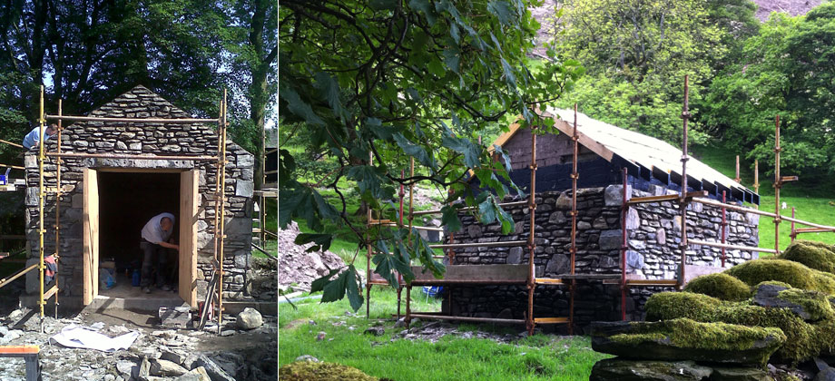

It would also be possible to run a hydro scheme in the Tweed, which would produce less energy (as there's less 'head') but which could be linked to a tourist attraction like a water wheel.

This type of scheme has minimal visual impact (unless a feature like a water wheel is involved).

(b) A large-scale solar project

It's not necessary to have constant sunshine to run a successful solar project!

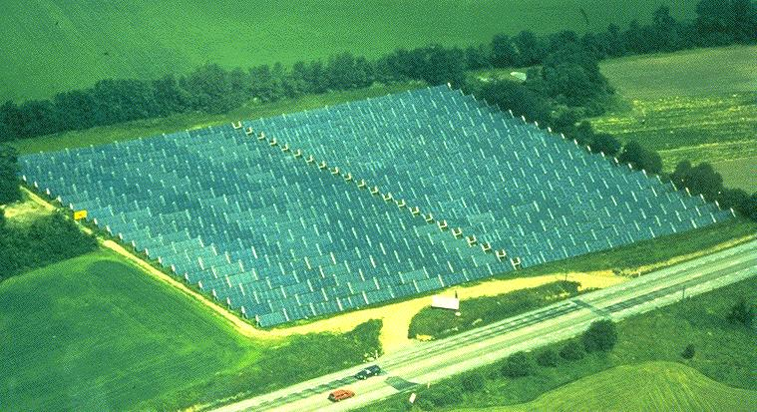
Solar panel field 8 Mw generation in full sun
This would involve installing a large number of solar panels (called a solar array) in an appropriate field or area which has a good orientation. This would obviously have much more visual impact than a hydro-turbine scheme. A solar array can be set up to have maximum benefits for wildlife, and can have the dual use of sheep and electricity production.

(c) A large-scale wind turbine project

Installation of a wind turbine similar to the ones installed locally, 3Mw in size but for the exclusive use of Tweedsmuir.

(d) A large geothermal system

- Ground source heat systems (extraction of heat from the ground)
- Water source heat systems (extraction of heat from a water source)

