Tweedsmuir gets creative! …Come and join us

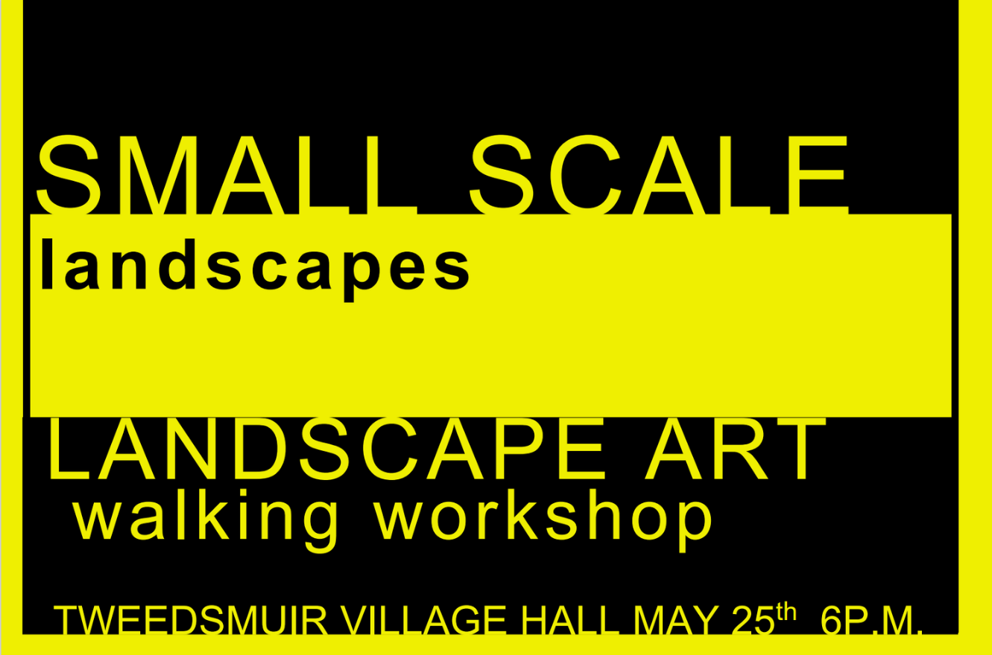

Wednesday 25th May Small Scale Landscapes Walk. Meet 6.p.m at the Village Hall.

This outdoors workshop is based around a walk. Its aim is to encourage volunteers, who wish to be involved in the project, to produce as many videos, sketches, photographs, or pieces of writing, as possible during the course of the walk. We will explore different ways of interpreting the landscape. These artworks will form the starting point for our development of the community artwork at the Crook.
This event will last roughly two hours. We should be back at the hall around 8 pm. Hopefully we will be blessed with some marvellous evening light! There will be refreshments in the hall afterwards.
Materials – All participants should bring a notebook or sketchbook. Participants are encouraged to bring any materials that they are particularly interested in using, for instance, something specialist such as camera. Drawing and painting materials will be provided. Please also come prepared for two hours outdoors. A rucksack could come in handy.

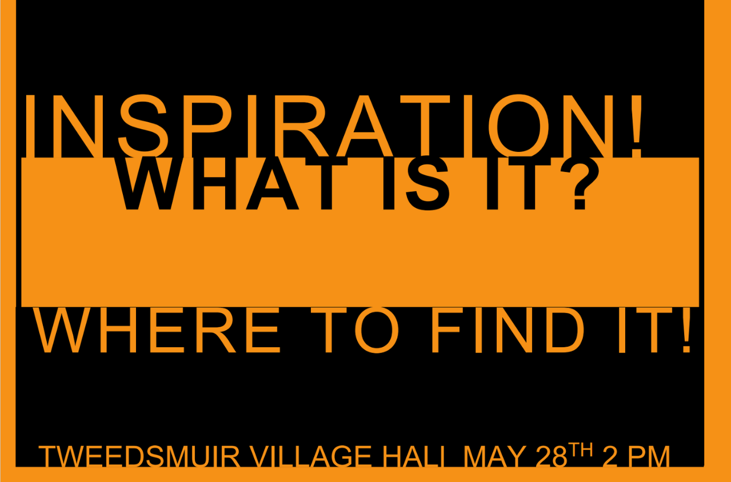

Saturday 28th May, Inspiration! Where to find it! Village Hall, 2 p.m. – 5 p.m.

Art History and Cultural Heritage – In this event we will cover a large variety of possible sources of inspiration for the community artwork at the crook. A presentation and activities will pose the questions: where can we look for inspiration? Could other artists offer ideas? How about the land itself? What might a finished artwork look like? What influences might be appropriate? What practicalities do we need to consider? We will try out some different materials, colours, and designs and work up some of the quick sketches and clips captured during the evening art-walk into more developed art works.
Please remember to bring your artworks from Wednesday or plenty of ideas and memories.
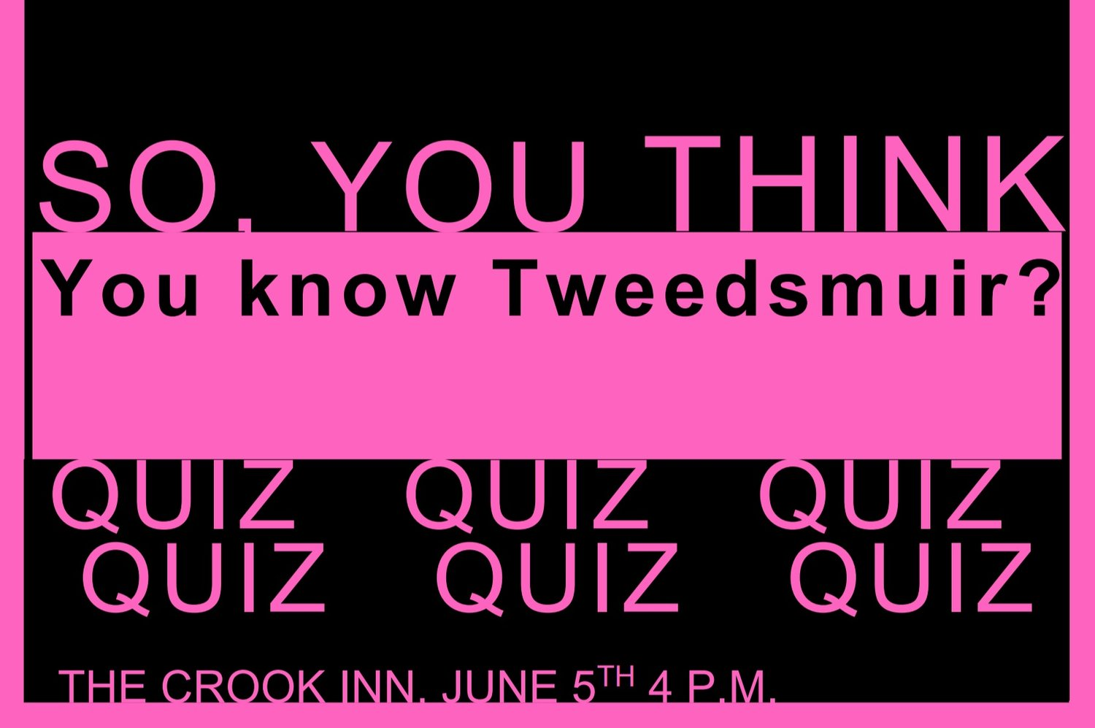

Sunday June 5th, Rhubarb Day

So, you think you know Tweedsmuir? The Crook Inn, 2 p.m. – 5 p.m. Quiz at 4 p.m.

This event will encourage people to think and talk about Tweedsmuir, with the aim of gaining an idea of what elements people think are important to include in the final artwork. The event will culminate in the Tweedsmuir Quiz at the Crook – how well do you really know Tweedsmuir? Can you ace rounds on Tweedsmuir's places, people, and history, along with a general knowledge round?
This event will also give participants the opportunity to show artworks created during events 1 and 2! There will also be the chance to participate in a collaborative textual artwork.
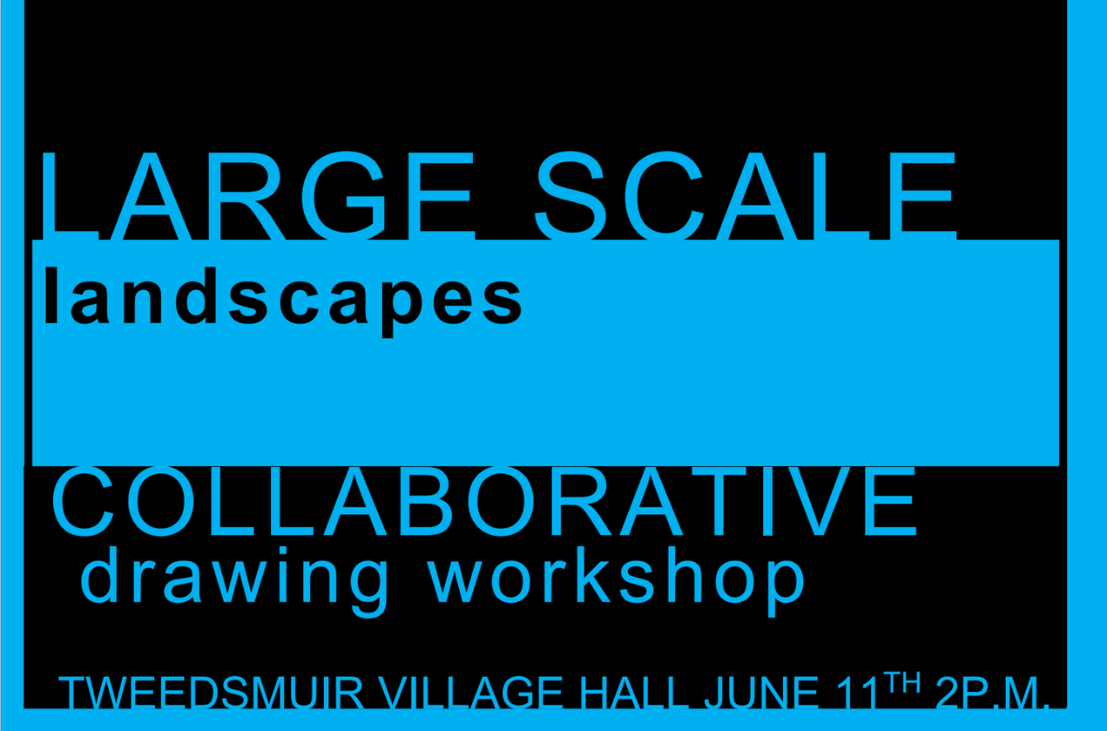

Saturday 11th June Large Scale Landscapes – The final plan, 2 p.m. The Village Hall

This is a workshop which will result in the production of the final design for the artwork surrounding the Crook Inn. It will begin with a recap of what ideas we have generated so far. The focus of the day to develop a large collaborative artwork at Tweedsmuir hall incorporating the elements discussed during the previous engagement events. By the end of the day the aim is to transform the collaborative artwork into a scale drawing which can be feasibly transferred to the hoarding surrounding the inn. This event will last three hours, or until the plan is largely complete...
The more the merrier! Please bring, sketches, ideas, and a willingness to compromise!
