Borders Buddies – expansion plans
Outside the Box have always aimed to fill gaps in statutory services to ensure people on the fringes stay connected with what should be their basic needs and rights. We are not a service provider as such, we promote community development and support people to help themselves.

Our pilot Borders Buddies project in Tweeddale (funded by the SBC Community Fund) supported people who had been disconnected during the pandemic to reconnect with basic things such as getting out to the shops or to a local group. To watch a short animation about the project, follow this link: https://biteable.com/watch/3527087/8c5f3e75b470c07ec8a9fa40154633ec
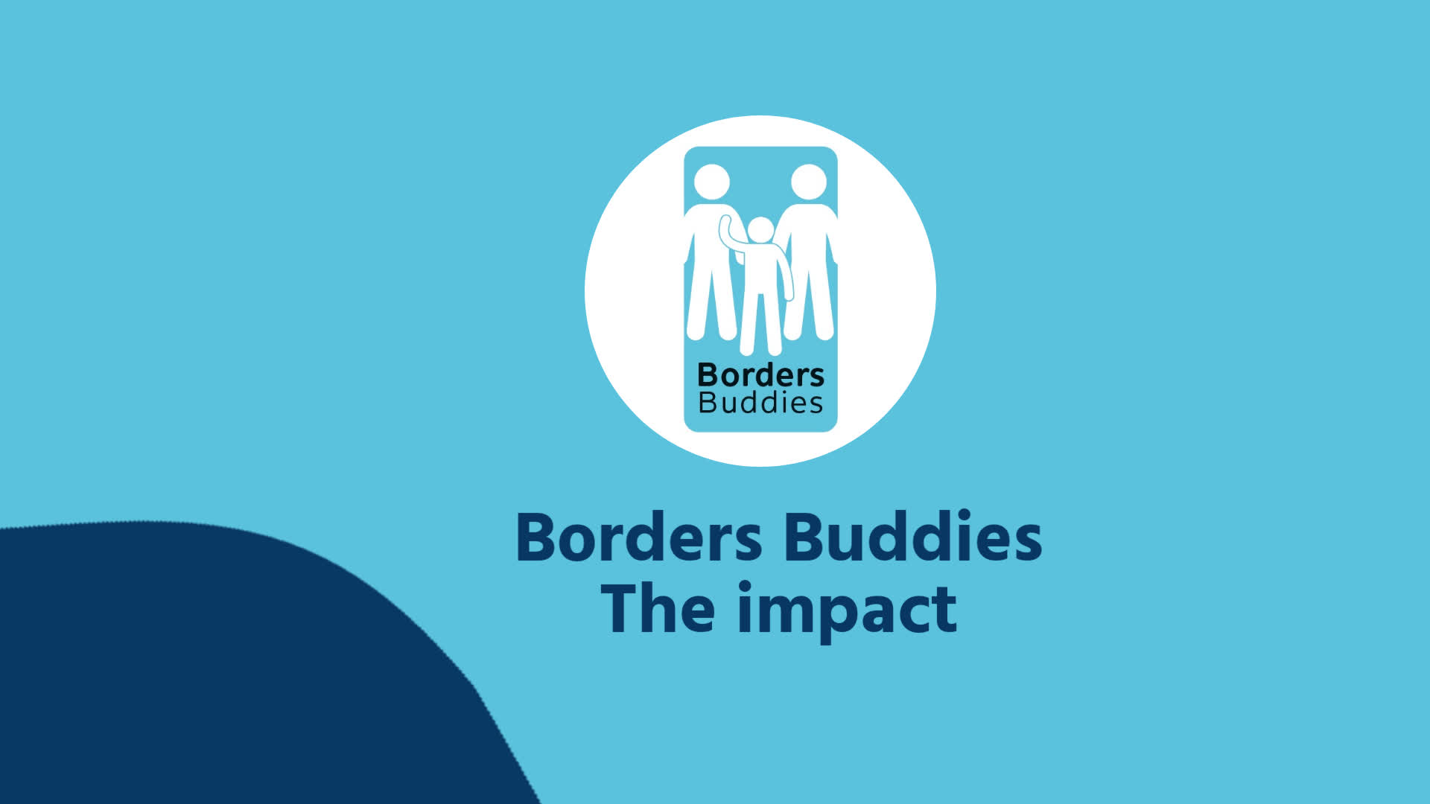 | Borders Buddies  Video made with Biteable. The World's Simplest Video Maker  biteable.com

We hope the worst of the pandemic is over, nevertheless we recognise that many people have always been in some way disconnected or isolated, and for some the aftermath of the pandemic will continue to exacerbate this. We have been speaking to individuals and groups all over the Borders, and through our networks all over Scotland, and we have been hearing that many people are still struggling to feel able to reintegrate themselves in 'normal' activities.

This is where Borders Buddies comes in - where appropriate, it matches people up with a volunteer to support them to get back to doing what they want to do. It also provides signposting; because we the way we work at a very local level, we have good knowledge of what is going on locally. We do this by employing a worker who lives in the local area and knows the local community well. Where groups or activities do not exist, we can support local people to try these out and start them up if there is a demand. Borders Buddies has also been instrumental in taking on local issues, for example access for less able people, and empowering these people to take on the issues themselves. It is very much an enabling, rather than a handholding project.
We are just at the expansion planning stage and want to check out that what we are hearing is right, that we are not duplicating what others are doing or stepping on any toes! We are all about filling gaps, partnership working and complementing what is being done, not reinventing the wheel!

We would like to continue to support people in the Tweeddale area, particularly in more remote outlying areas where access to activities and facilities may be more problematic.

Could you see Borders Buddies working in your local area? Do you know people who have slipped between the gaps, invisible or ineligible for other supports? Are there local issues around access, transport, the right to good food or tenants' rights which are not being addressed? Are there people - older people, young people out of work, less able people - who might benefit from Borders Buddies?

If so, please drop us an email, and we will follow up soon. Please do feel free to share on with colleagues or others.

Thanks in advance,

Ruth

Ruth Noble
Development Worker
Outside the Box

Mobile: 07711 210431
Ruth.n@otbds.org

