Images and videos you can use on social media:

- Link to google drive with images and videos
- Youtube video introducing Whitelaw Brae wind farm

Suggested text for email / newsletter update:

Whitelaw Brae Wind Farm Update - Cooperative Share Offer
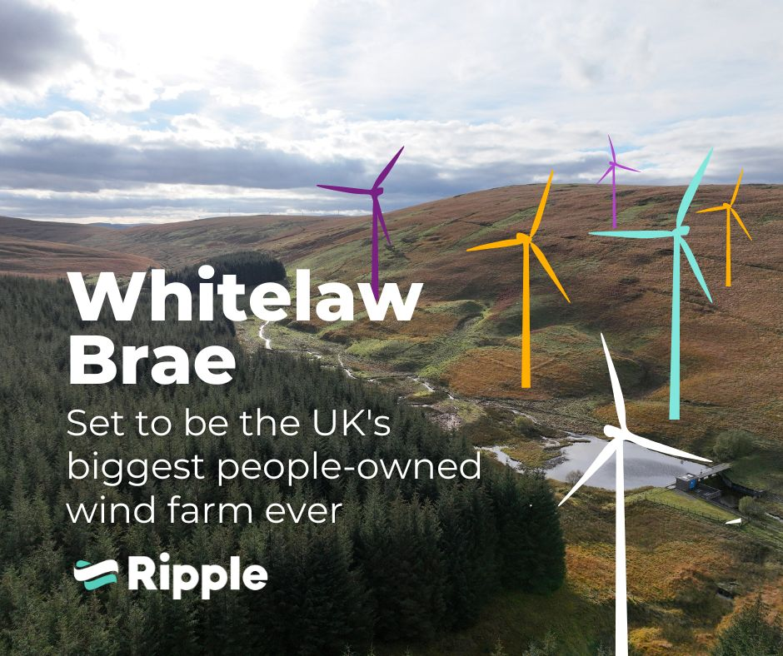
We have had an update from BayWa r.e who have developed the 14 turbine Whitelaw Brae Wind Farm that will be constructed south of the A701 and to the west of Fruid Reservoir. They were joined by representatives of Ripple Energy.

Ripple Energy's business model is to enable cooperative ownership of renewable energy projects, which means households and businesses in our local area can also be owners of Whitelaw Brae.

Ownership starts from £25. By becoming a member of the wind farm co-operative you are then allocated your share of the power that is generated and this then gives you savings on your electricity bills for the 30 year life of the wind farm.

WATCH: Introducing Whitelaw Brae Wind Farm

The share offer is due to close at the end of May, so if this is of interest please do have a look.

About Whitelaw Brae Wind Farm
- 14 turbines are expected to generate around 145GWh of green energy each year. That’s the potential to power around 54,000 homes.
- In just three minutes, at full capacity, it will generate enough electricity to power a typical home for a year.
- For typical households, it will save around 1,400kg CO2 emissions each year.
- Around £1,900 will buy enough of the wind farm to power 100% of a typical family home’s electricity needs.
- The wind farm is expected to start operating in late 2026.

How to join Whitelaw Brae Wind Farm
- Read the share offer document in full. This is important and contains all the information you need.
- Decide how much you want to buy using Ripple Energy’s quote calculator.
- Click “Buy Now” on Ripple Energy’s website
- Confirm your purchase, paying in a one-off payment or in 12 monthly instalments.
- Welcome aboard! You’re now the proud owner of your own source of green energy!

