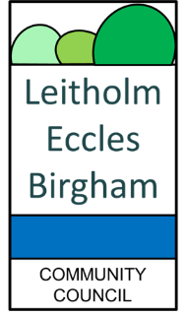
INVITATION TO COMMUNITY COUNCIL CONVENTION ON THE IMPACT ON COMMUNITIES OF MAJOR ENERGY INFRASTRUCTURE IN SCOTTISH BORDERS AREA
Saturday 17th January, 2026 between 2pm and 4pm
THE TOWN HALL, JEDBURGH

As you know, the speed of renewable energy infrastructure developments has gathered pace, with many of us being under considerable pressure to respond to complex and lengthy renewables applications, with many ultimately being approved by the Energy Consents Unit or Scottish Ministers.
The speed of transformational change is enormous. It is more important now, than ever before, that our impacted communities come together and try to speak with a combined voice on behalf of those who are being adversely impacted. This stronger, combined community-based voice should seek a place at the top table when decisions are made regarding our landscape, way of life and heritage.
Some of us know of people who are moving away from impacted areas or who are seeing a reduction in the value of their homes and businesses, not to mention health and wellbeing impacts. That needs to be recognised and addressed at the top table.
To this end, we are proposing to hold a Convention of our Community Councils who are adversely impacted by major energy infrastructure, similar to that which was organised and chaired by Councillor Helen Crawford in The Highland Region earlier this year. Those Highland Conventions resulted in over 50 Community Councils agreeing the wording of a Unified Statemen, drafted by Councillor Crawford and which I attach. It calls for a pause to major renewables applications given that there is no holistic national energy strategy in place and there is a clear lack of analysis of the cumulative impact on our landscape, nature, general amenity and way of life. Those Highland Conventions concluded with 11 Highland MPs and MSPs giving a commitment to seek urgent cross-party debates on the unified statement in Westminster and Holyrood. All of this obtained significant national press coverage and has ensured that this matter is firmly on the political table. We would like, if possible, to add to that momentum and ensure that collectively our voice is heard.
We are proposing to hold a similar Convention on Saturday 17th January 2026, at The Town Hall, Jedburgh from 2pm to 4pm, in order to give voice to our impacted Community Councils and communities, and, if agreed, to join forces with the Highland Convention and others to collectively press for action at national level.
Councillor Helen Crawford has kindly accepted an invitation to attend and to speak on the Unified Statement and provide help as best she can.
We want to stress that this Convention would be open for anyone to attend and observe and that all political parties should also be invited to attend and hear what our Community Councils have to say. The intention is that the event will be apolitical.
It is hoped that we will be able to arrange for people to join the event remotely either via Teams or Zoom. Presence in person would be greatly appreciated.
Please confirm your attendance to leitholmecclesbirghamcc@gmail.com by 20th December, 2025 indicating whether you can attend in person or on Teams.
Yours Faithfully,
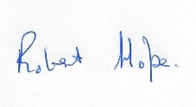
Chair,
19th November, 2025

